**ELIAS NGUGI KARIUKI**

**SCT221-0270/2017**

**ICS 2311: COMPUTER GRAPHICS CAT II**

1. **DEFINE COMPUTER GRAPHICS AND DESCRIBE FIVE APPLICATION AREAS FOR COMPUTER GRAPHICS**

Computer graphics is the creation manipulation and storage of geometric objects and their images

*Application areas*

* it is used in the entertainment industry in the development of games, animations and cartoons
* in computer aided design whereby it is used in engineering and construction and can thereby be used to model structures to be built
* Education and training whereby graphics has been widely used to create informative content as learning materials that explain certain phenomena
* Presentations, graphics have been widely used in presenting more relatable information in an easier manner, presenting data such as statistics in graphic forms like graphs or pie charts
* Use in biology where molecular biologists can display pictures of molecules and therefore get a better picture of different structures

1. **LIST DOWN FIVE COMPUTER GRAPHICS PRIMITIVES**

* Pixel – smallest unit of a digital image that can be displayed and represented on a digital display device
* Points and Lines – points are used as the foundations for more complicated shapes while a line is a container for all 2D points(x, y) which satisfy the equation ax + by + d = 0
* Polygon – a closed area of an image bounded by straight or curved lines filled with one solid color
* Display control- controls the view of the image so that the user can view the image from a desired angle
* Frame buffer- video output device which drives a video display from the memory buffer containing a complete set of data

1. **BY USE OF A DIAGRAM EXPLAIN THE MECHANISM OF THE COLOUR CRT MONITOR**

Shadow mask method - This type of CRT has 3 electron guns, one for each color dot and a shadow mask grid just behind the phosphor coated screen.

The deflection system of the CRT operates on all 3 electron beams simultaneously; the 3 electron beams are deflected and focused as a group onto the shadow mask, which contains a sequence of holes aligned with the phosphor- dot patterns.

When the three beams pass through a hole in the shadow mask, they activate a dotted triangle, which occurs as a small color spot on the screen.

The phosphor dots in the triangles are organized so that each electron beam can activate only its corresponding color dot when it passes through the shadow mask.

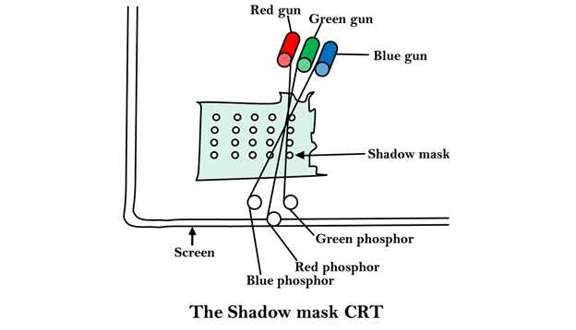

1. **OUTLINE THE GENERAL STRUCTURE OF AN OPENGL PROGRAM AND EXPLAIN THE USE OF VARIOUS OPENGL LIBRARIES**
2. **EXPLAIN THE USE OF VARIOUS OPENGL LIBRARIES NAMELY GL, GLUT GLU GLUI**
3. **USE A DIAGRAM AND EXPLANATIONS TO ILLUSTRATE THE WORKING MECHANISM OF A RASTER SCAN CONTROLLER**